**Module 1 : Design Patterns in Java**

**Exercise 1: Implementing the Singleton Pattern**

**Scenario:**

**You need to ensure that a logging utility class in your application has only one instance throughout the application lifecycle to ensure consistent logging.**

**Solution :**

**Step 1 ,2,3**

**Code :**

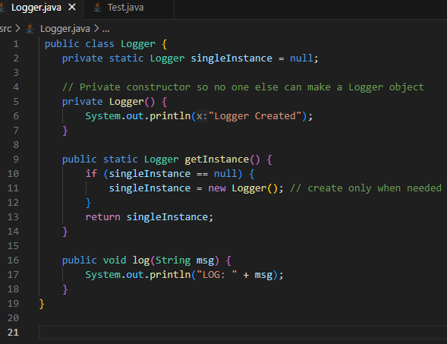

**Step 4**

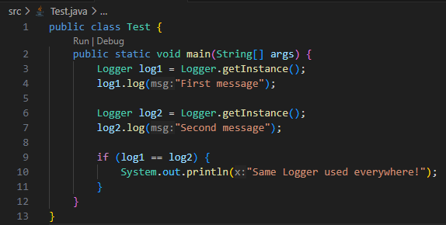

**Output:**

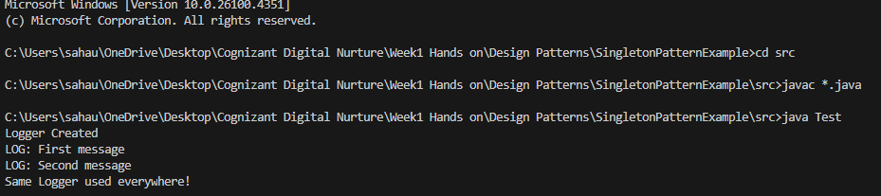

**Exercise 2: Implementing the Factory Method Pattern**

**Scenario:**

**You are developing a document management system that needs to create different types of documents (e.g., Word, PDF, Excel). Use the Factory Method Pattern to achieve this.**

**Solution :**

**Code :**

**Step 1 and 2**

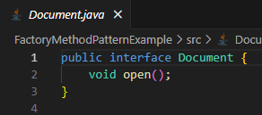

**Step 3**

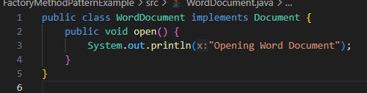

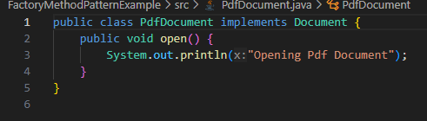

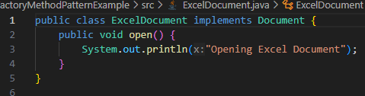

**Step 4**

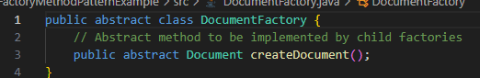

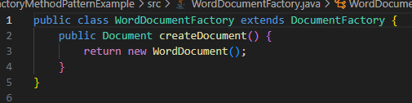

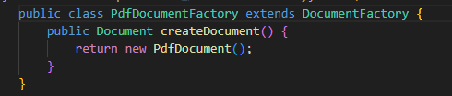

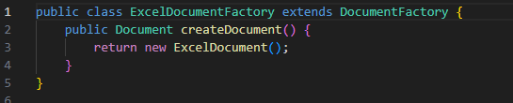

**Step 5**

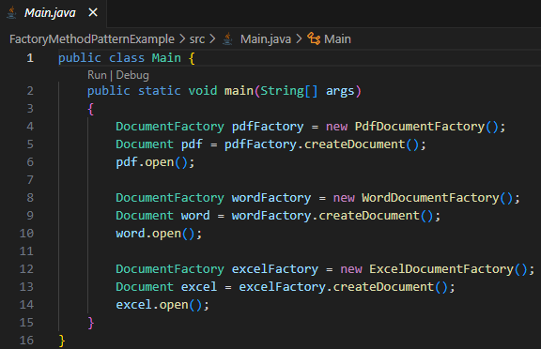

**Output :**

